IN723 Lab 8 BGP Integrated

In this lab we will configure a dual homed site utilizing features of BGP, OSPF, HSRP, STP and Etherchannel. Each site will be connected to a common hub site for interconnectivity.
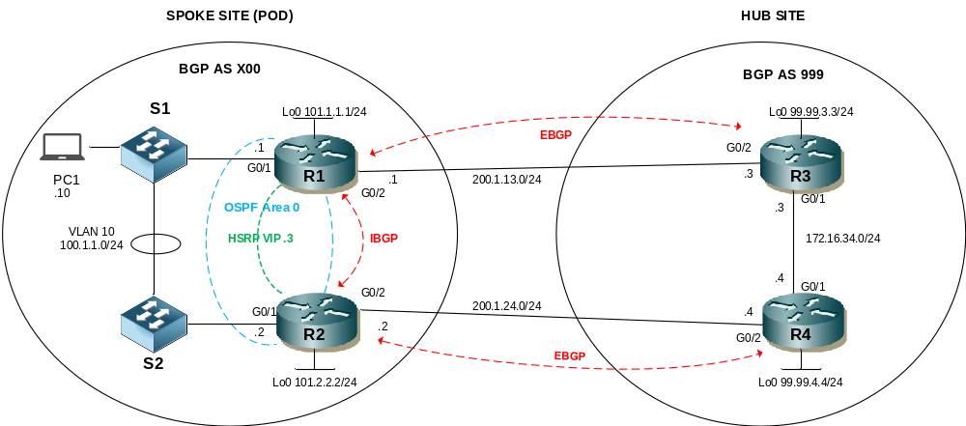

- Note – This lab cannot be completed in packet tracer (unsupported BGP commands). You can use VIRL or GNS3.
- You may need to clear BGP sessions or issue a soft reset for some changes to take effect
- L2 & HSRP steps are optional and can be completed independently of OSPF & BGP.

Step 1 - Physical
- Physically cable the lab as per the above diagram using VIRL IOSv routers and IOSvL2 switches

Step 2 – IP addressing
- Configure IP addressing as per the diagram or below table
- Ensure the interfaces are not shutdown

Interface | IP Address | Default Gateway
SpokeR1 G0/1 | 100.1.1.1/24
SpokeR1 G0/2 | 200.1.13.1/24
SpokeR1 Lo0 | 101.1.1.1/24
SpokeR2 G0/1 | 100.1.1.2/24
SpokeR2 G0/2 | 200.1.24.2/24
SpokeR2 Lo0 | 101.2.2.2/24
PC1 | 100.1.1.10/24 | 100.1.1.3 (HSRP VIP)
HubR3 G0/1 | 172.16.34.3/24
HubR3 G0/2 | 200.1.13.3/24
HubR3 Lo0 | 99.99.3.3/24
HubR4 G0/1 | 172.16.34.4/24
HubR4 G0/2 | 200.1.24.4/24
HubR4 Lo0 | 99.99.4.4/24

- Note the router acting as a PC can be configured with a default route pointing to 100.1.1.3 to simulate a default gateway

Step 3 – Configure Layer 2 (optional)
- Create VLAN 10
- Configure S1 & S2 to use Rapid PVST+ spanning tree
- Configure S1 as the root bridge for vlans 1 & 10

- Configure etherchannel using LACP for the 2 ethernet links between S1 and S2 (note configure the etherchannel and trunk settings in strict order as shown below)
- Ensure the etherchannel is neogotiated
- Configure the etherchannel as a Trunk that will only carry VLANs 1 & 10
- Ensure the trunk is non negotiable
interface range g0/2 – 3
switchport trunk encapsulation dot1q
switchport mode trunk
switchport trunk allowed vlan 1,10
switchport nonegotiate
channel-group 1 mode active

- Configure the PC1 user port in VLAN 10
- Configure the ports for R1 & R2 in VLAN 10
- Ensure all user ports will transition to forwarding immediately.

Step 4 – HSRP (optional)
- Configure an HSRP standby group on R1 and R2 for the VLAN 10 network

Group | VIP | Priority R1 | Priority R2
For VLAN 10 | 100.1.1.3/24 | 105 | 100 (default)

- Ensure the routers can preemptively take control if they have a higher priority
- Ensure that HSRP tracks the state of the WAN interface on R1 and R2 and will decrement the standby priority by 10 (default) if it goes down (Note the configuration for tracked interfaces differes in VIRL, a tracked object number is specificed instead which references an interface, see below).
e.g. On R1

track 1 interface GigabitEthernet0/2 line-protocol

interface GigabitEthernet0/1
ip address 100.1.1.1 255.255.255.0
standby 1 ip 100.1.1.3
standby 1 priority 105
standby 1 preempt
standby 1 track 1 decrement 10

Step 5 – Configure OSPF
- Configure OSPF on R1 & R2 to use the loopback IP address as the router ID
- Ensure that OSPF can calculate costs for gigabit links less than 100mb
- Ensure R1 is elected DR for the multi access LAN segment between R1 and R2
- Activate OSPF on the router LAN interfaces in AREA 0
- Advertise the loopbacks of R1 & R2 as OSPF internal routes

Step 6 – BGP Peering
- Configure BGP AS 100 on R1 & R2
- Configure BGP AS 999 on R3 & R4
- Configure fixed BGP router-ids using the loopback IP addresses
- Configure IBGP between R1 and R2 using the loopback interfaces for peering.
- Ensure next-hop-self is set for prefixes advertised between R1 and R2
- Configure IBGP between R3 and R4 using the LAN interfaces (g0/1) for peering.
- Ensure next-hop-self is set for prefixes advertised between R3 and R4
- Configure EBGP between R1 and the hub sites R3 using the WAN interfaces for peering
- Configure EBGP between R2 and the hub sites R4 using the WAN interfaces for peering

Step 7 – Advertise Networks
- Advertise the LAN network (VLAN 10). Ensure the origin code is i
- Advertise the loopback networks of R1 & R2. Ensure the origin code is ?. Use a route-map to ensure only the loopbacks are advertised this way (hint – you can match ip address or match interface)
- Advertise the loopback networks on R3 & R4. Ensure the origin code is i

Step 8 – BGP Policy
- Use the aggregate-address command on R1 and R2 to advertise a single summary representing both loopback addreses. Ensure the specifics are suppressed
- Configure the summary prefix with the community no-export to ensure it is not advertised beyond the hub site. Do this with an outbound route-map for R1 to R3 & R2 to R4. Note you will also need to configure R1 & R2 for send-community.
e.g on R1

access-list 1 permit 101.0.0.0 0.255.255.255

route-map set-community permit 10
match ip address 1
set community no-export

route-map set-community permit 20

router bgp 100
neighbor 200.1.13.3 send-community
neighbor 200.1.13.3 route-map set-community out

- Configure BGP so that R1s WAN link to R3 is the preferred path for all outbound traffic destined to R3’s loopback address. Use a prefix-list. (hint use inbound route-map matching ip prefix-list and setting local-pref for neighbor 200.1.13.3).
- Configure BGP so that R2s WAN link to R4 is the preferred path for all outbound traffic destined to R4’s loopback address. Use an access-list.
- Configure BGP so that R2s WAN link to R4 is the preferred path for all inbound traffic to the 101/8 aggregate created earlier. Note you will need to modify the set-community route-map as you are only allowed to configure one outbound route-map per neighbor.
route-map set-community permit 10
set as-path prepend 100 100

Note: You could have removed the route-map and edited it with a new name then readded it.

Step 9 – Testing
- Ensure PC1 can ping 99.99.4.4 & 99.99.3.3
- Confirm R1 is the primary path out of your AS to R3s loopback
- Confirm R2 is the primary path out of your AS to R4s loopback
- Confirm R1 is the primary path into your AS

